University of Sulaymaniyah

College of Science

Computer Department

4th Stage

**Forecasting Earthquakes: Predicting Future Seismic Events in 2024 and Beyond**

**Prepared by:**

Gashtyar Mahmood Abdullah

Mohammed Salah Rahim

Brwa Ibrahim Mustafa

Zhyar Sabah Wali

**Prepared for:**

Dr. Miran Taha Abdullah

**2023-2024**

Contents

Introduction

Problem Statement

Solution Method

Implementation

Results Discussion

Project Conclusion

**Introduction**

This dataset includes a record of the date, time, location, depth, magnitude, and source of every earthquake with a reported magnitude of 5.5 or higher for year 2022 compiled by The National Earthquake Information Center (NEIC).

**Problem Statement**

Develop a model to predict the time of future earthquakes by analyzing a provided dataset. Given a dataset of seismic activity measurements, the goal is to develop a predictive model that can accurately determine the time of future earthquakes.

**Solution Method**

The code begins by importing necessary libraries such as numpy, pandas, matplotlib, and seaborn. The dataset is then loaded from a CSV file and pre-processed by removing missing values.

calculates the correlation matrix of the dataset and visualizes it using a heatmap. The code also creates scatter plots and 3D plots to visualize the relationship between different variables such as longitude, latitude, and magnitude.

also calculates the mean and median of the magnitude and depth variables and creates box plots and violin plots to visualize their distribution. The code also creates a regression plot to visualize the relationship between magnitude and depth.

Overall, the code appears to be an exploratory data analysis of the earthquake dataset, with a focus on visualizing the relationships between different variables and identifying any patterns or trends.

**Implementation**

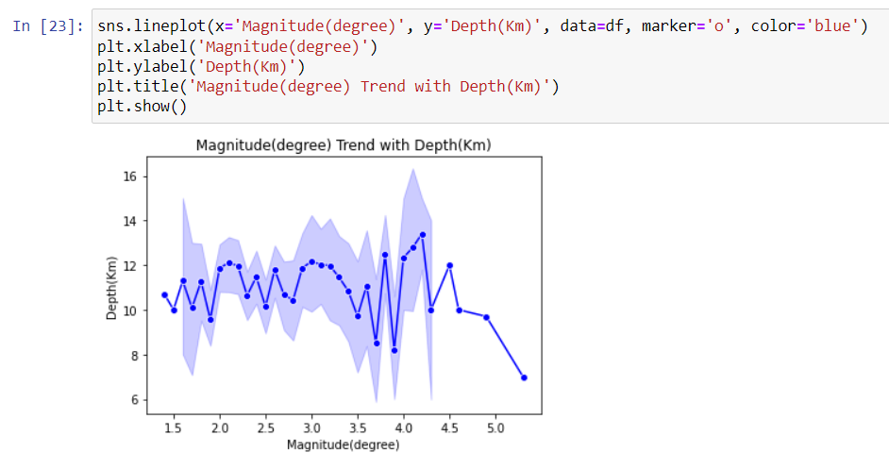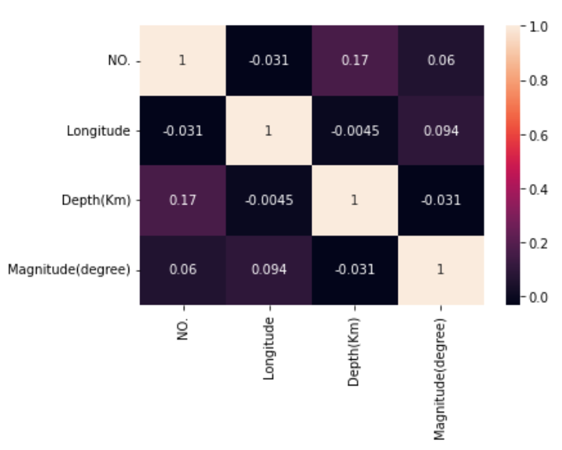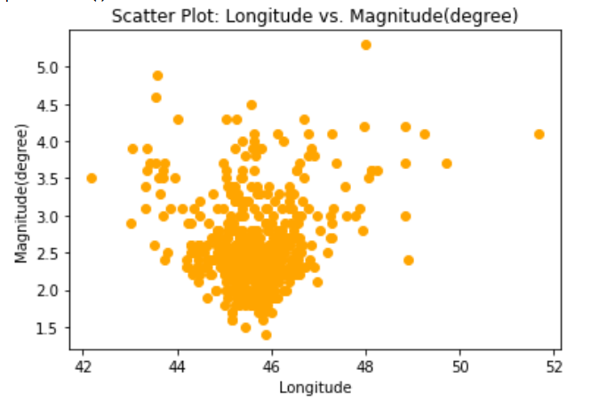

**Result Discussion**

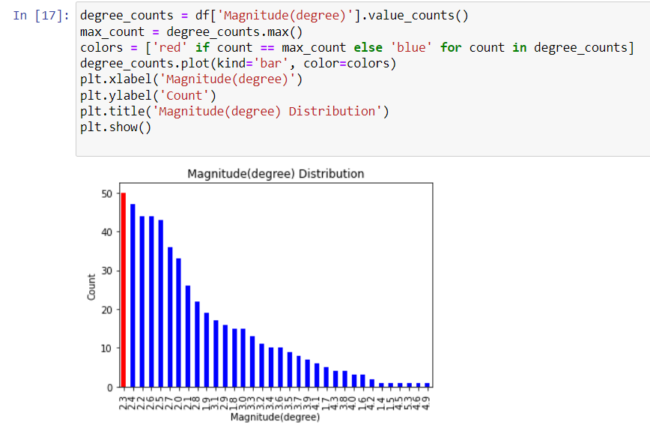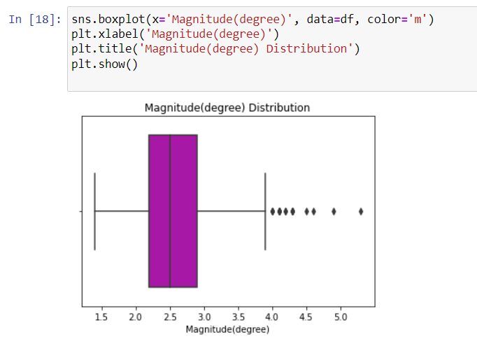

**Project Conclusion**

While significant progress has been made in understanding the causes of earthquakes, determining the exact time of an earthquake's occurrence within a specific time frame, such as a week, remains a major challenge. Current technology and methods can provide general warnings for seismic activity but cannot predict the exact time of an earthquake's occurrence. Therefore, it is crucial to focus on developing resilient communities and infrastructure to mitigate the impacts of earthquakes.